Chapter
The Relationship between Mental Health and Resilience: A Systematic Review
¹Dr. Vandana Gaur and ²Dr. Anil Bhatt

¹Associate Professor, Dept. of Psychology, SDM Government PG College Doiwala
²Assistant Professor, Dept. of Sociology, SDM Government PG College Doiwala
Email: vandanagaur97@gmail.com

ABSTRACT
This study employs the descriptive technique to investigate the relationship between resilience and mental health. A person's resilience is a psychobiological trait that influences how they react to negative life situations. The ability to quickly and effectively adjust to stressful or painful situations and return to a happy mood is known as resilience in humans. It is essential to the development of positive psychology, which addresses people's life satisfaction, flexibility, contentment, and optimism. Resilience is a risk factor for some clinical diseases as well as a preventive factor against the emergence of mental disorders. In this Review, we hope to increase the comprehension of several interrelated systems among mental health professionals that support the mental well-being of people facing unusual stress.
Keywords: mental health, psycho-social, resilience
INTRODUCTION
The World Health Organization's (WHO) definition of health places emphasis on the positive aspect of mental health. The definition highlights; “Health is a state of complete physical, mental and social well-being and not merely the absence of disease or infirmity.” Subjective well-being, perceived self-efficacy, autonomy, competence, and the awareness of one's capacity to reach one's full emotional and intellectual potential are all considered aspects of mental health. It can also refer to a state of well-being in which people accept their own skills, are able to manage life's typical stressors, work effectively and efficiently, and give back to their communities. Improving people's and communities' capacities and empowering them to fulfil their own objectives are central to mental health (WHO 2002).
Increasing amounts of cross-cultural research show that a range of behavioral, social, and psychological variables can promote and safeguard for good mental health. This kind of protection speeds up the healing process after illness, reduces and delays the onset of impairments, and increases resistance (resilience) to disease (WHO 2002). Individual coping strategies for stress, problem-solving, and overcoming hardship without collapsing have always been at the core of mental health.
Towards mental health and resilience – the most difficult challenge
It is apparent that mental health and resilience are two interrelated constructs since they determine as well as define the ability of the individual to deal with various challenges and stressors in life. The objective of this systematic review is to provide answers as to how these two constructs are related to each other by giving information from recent studies and extracting significant conclusions from the reviewed materials.
Conceptual Definition
Mental health encompasses individual’s emotion, his psychological condition, and social contacts as well. It determines how that individual will cope with stress, how he will interact with the society and what choices he will make (World Health Organization, 2021). Resilience in turn has been explained as a concept which imbues the capability of individuals to regain their loss, withstand any difficult situation and continue functioning on a normal level (Southwick et al., 2014). Resiliency and overthrow is not natural but can be nurtured over a period of time through experience, social support, and relevant interventions (Windle, 2011).

What does resilience look like in practice?
Resilience is the ability to adjust effectively in the face of trauma, tragedy, threats, or other major causes of stress, according to the American Psychological Association (APA). Some people might recover more readily from personal trauma or setbacks than from work-related setbacks and vice-versa. Nobody is naturally resilient, though resilience is a talent that must be developed via experience as well as deliberate thinking, behavior and action development. Resilience has the following qualities according to studies that led to the creation of Conor- Davidson Resilience Scale (CD-RISC)
- Viewing change as a challenge or opportunity
- Commitment
- Recognition of limits to control
- Engaging the support of others
- Close, secure attachment to others
- Personal or collective goals
- Self-efficacy
- Strengthening effect of stress
- Past successes
- Realistic sense of control/having choices
- Sense of humor
- Action-oriented approach
- Patience
- Tolerance of negative affect
- Adaptability to change
- Optimism
- Faith
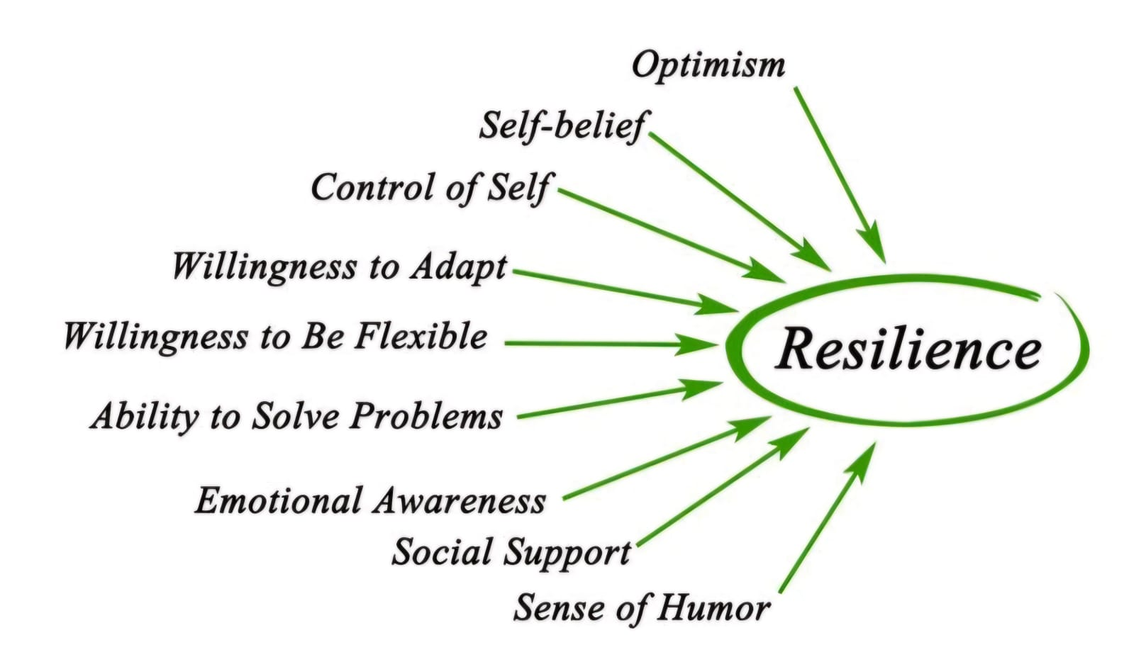

Psycho-social-Factors
There is a compelling argument that resilience builds resilience, and while there may be a correlation between some neurobiological changes and trauma, it is unclear if these changes alone will determine the type and intensity of a person's response to trauma. The level for resilience protection and modification also depends on other complex factors that shape the influence resilience on individuals experiencing trauma.[ Rutter M. 2012]. Resilience is a human capacity to adapt swiftly and successfully to a stressful/traumatic events and manage to revert to a positive state. [ Manyena SB 2006] Thus, resilience has a major impact on people's health state and offers a potential preventive tool for mental illness.
There appears to be a considerable association between engrained psychosocial elements and resilience's ability to function as a protective measure. The factors that act to maintain and uphold resilience are active coping, cognitive flexibility, and social support.[ Genet J, Siemer M. 2011] Active coping is one's life long acquired ability to utilize psychological and behavioral resources to cope with trauma or stressors.[ . Steinhardt M, Dolbier C 2008].Apart from assisting in active coping, cognitive flexibility also plays a role in fostering and preserving resilience—the ability to tolerate adversity.[12] Human intellect is built to change with the conditions, rising to the challenge.[In 1999, Dumont M and Provost MA] In order to minimize potential harm, cognitive flexibility enables an individual to dynamically adapt to external constraints resulting from trauma. The basis for cognitive resilience's flexibility is acquired information that has grown throughout a person's life and allows them to bend their thinking to deal with trauma more effectively. [Dumont M, Provost MA 1999]
Significance of the Study
This study is significant because it addresses a factor that has gained prominence recently and has a broad effect on a person's capacity to manage psychological strain and stress. This study contributes to our understanding of the relationship between resilience and mental health, which will help to enhance mental health within the study population.
Previous Studies on Resilience & Mental Health
Without mentioning resilience, a discussion about positive mental health would be lacking. Resilience is frequently defined as the component of mental health and coping that is essential to one's capacity to bounce back from difficult situations. Resilience is the capacity to "bounce back from adversity" and is related to both general physical and psychological health.[Seligman 2011; Reivich KJ] The ability of an individual to enjoy life and strike a balance between life's activities and attempts to develop psychological resilience has long been emphasized by positive psychology approaches.
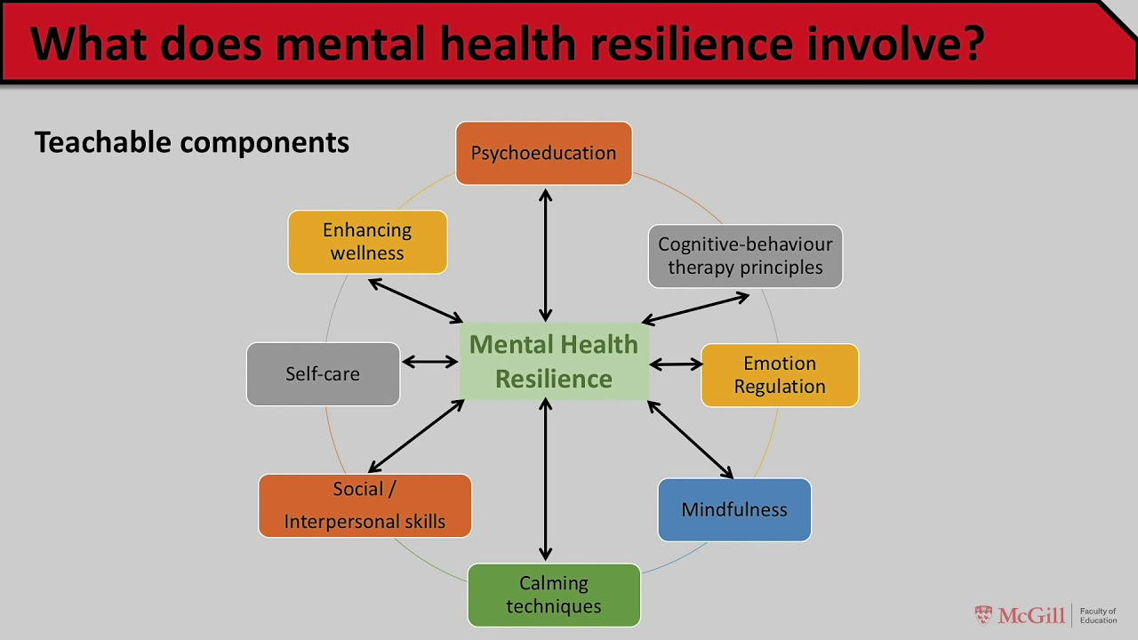
What differentiates resilience from other concepts and variables related to mental health is that the effectiveness of other concepts is focused on the mechanisms of facing pressure while resilience, on the other hand, takes things a step further; it deals with learned experience and the hidden lessons found in difficult situations. Resilience entails viewing difficult situations as opportunities for perseverance and for rising beyond oneself, even in the face of unfavorable external conditions. According to Ryff, Friedman, Fuller Rowell, Love, Miyamoto, Morozink, and Tsenkova (2012), these encounters could also be viewed as assessments of one's ability to overcome obstacles rapidly. In terms of thoughts, feelings, behaviour, and spirituality, this enables the person to discover the foundation for their own progress (Kumpfer, 1999). According to the American Psychological Association, psychological resilience and mental health are related. This means that there are various facets, models, and conceptions of mental health that are occasionally regarded as forms of resilience that help people overcome hardship. (American Psychological Association, 2017; Newman, 2005). Todd and Rotenberg (2010, p. 866) also consider psychological resilience a main complementary component of mental health, as it is a main contributor to lasting well-being and mental health. Additionally, mental health and psychological resilience enhance each other (Kajbafnezhad & Keshi, 2015).h
Resilience is noted to be trainable.[ Luthar SS, Cicchetti D & . Connor KM, Davidson JR 2003].Various researchers have contributed to the understanding of trainability dimension of resilience. However, the evidence suggests that it is a part of nature and nurture dimension. The growing evidence supports the notion that resilience is involved in the development of positive psychological traits.[ Bonanno , Loss 2004] Various studies have illustrated the critical role of resilience on the individuals’ capacity to form a healthy response while enduring trauma, and this has been noted across all ages.[ Sarchiapone M 2009 ] Humans are capable of defending themselves against harmful stimuli or situations that could upset their psychobiological equilibrium. Resilience shows itself in this regard as a component that helps function as a protective and defence mechanism.
The person can build a repository of significant knowledge with this learned content, which can offer a framework for processing novel stimuli. Consequently, when trauma-based stimuli arise, a person with a larger knowledge base may be better able to adapt cognitively to the issue at hand and lessen the trauma's negative effects.
Social support is the final component that goes into the structure and operation of resilience.[Birnie-Lefcovitch S, Armstrong MI, 2005] According to some definitions, resilience is a dynamic system that results from interactions with elements other than an individual's inherent characteristics.[ Begun AL 1993]. Resilience is significantly impacted by the social environment in which an individual lives since it enables them to respond positively to obstacles or threats.
An individual's ability to be resilient is strongly influenced by the caliber of their social support system. It has been determined by researchers that increased global cognitive functioning is positively correlated with social support, social activity, and the caliber of those social ties Karatsoreos IN, McEwen BS. 2013].They have also suggested that a person's social support may help mitigate harm from trauma if there are more people in their network. All of these findings bear out the importance of those relationships to an individual. [Youssef NA, Green KT, Beckham JC 2013] Therefore, it can be argued that the psychosocial relationship between the three closely related factors (active coping, cognitive flexibility, and social support) is the bases in order to cultivate, employ, and preserve resilience in the face of stressful circumstances. Additionally, the possibility that the person will be protected from trauma-related harm increases if the three components are appropriately established.
Positive psychology is a major effect on positive mental health techniques and resilience building, which are closely associated with the global mental health perspective. The ability and performance of an individual in fulfilling societal standards in the face of significant adversity is a common behavioral indicator of resilience.[Schoon I, A. Sacker, J. Fagg, S. Curtis, S. Stansfeld,2006].
One way to describe the modern era is as a time of difficulties and competitiveness. These qualities contribute to the establishment of an ecological equilibrium that is robust and positive, which in turn helps to improve the mental health of coming generations.
Resilience can be modified. A few examples of this include maintaining a psychological state that provides protection against adversities in both acute and chronic conditions, lowering the level of pathogenesis during the process of developing from health to disease, and enabling return to the initial stage after the unfavorable circumstance has changed.
Individuals with high resilience have the capacity to “bounce back” after experiencing traumatic event, and/or the ability to recover from difficulties/changes.[ Calhoun LG, Tedeschi RG 2014 ] It is possible to make resilience the central idea of numerous interventions in order to accomplish a wide range of intended results. The broader public stands to gain greatly from resilience programs, which improve people's capacity to handle adversity. This advantage extends beyond individuals with mental illnesses. You may describe the modern period as one of competition and challenges. Such qualities contribute to the establishment of a robust and beneficial ecological equilibrium, which in turn helps to improve the mental well-being of coming generations.

Key Findings from the Systematic Review
- Resilience in Mental Health Problems- One of the most consistent findings across studies is that resilience is a protective factor in mental health. Studies suggest that individuals who have higher resilience levels are prone to lower suffering from anxiety, depression and stress disorders (Tugade & Fredrickson, 2004). Such people are prone to utilize adaptive coping strategies, positive self-perception and emotional regulation, which act to sustain them psychologically in hostile environments (Luthar et al., 2000) even at worse times.
- Intervention’s Effect on Mental Health and Resilience Development -Numerous studies indicate that there is a complex and bidirectional interaction between mental health and resilience. Alongside the fact that resilience enhances an individual’s mental health, good mental health also enhances an individual’s resilience (Masten & Reed, 2002). Mental health serves as a stability from which people draw the versatility and endurance needed to cope with stress and to learn.
- The Importance of Social Networks in Improving Resilience- Social support as reported by participants is one of the areas that correlates with resilience and resilience. Support networks such as family, friends, and community resources have been said to have a better for individual’s mental wellbeing in that they can help mitigate stressors (Ozbay et al., 2007). It has been found that people who have sufficient social networks suffer from less psychological disorder as they are likely to cope with the adverse situations in a better way.
- Practices That Aim at Increasing Resilience and Bettering Mental Health -Throughout several studies, resilience-evidenced practices like Cognitive Behavioral Therapy (CBT), mindfulness, and stress management have suggested a better correlation with an improvement in mental health (Robertson et al., 2015). These interventions further not only enhance resilience but also decrease the symptoms of anxiety and depression in order to help the stressors themselves (Joyce et al., 2018).
- Vulnerability Factors- Adverse childhood experiences (ACEs), Social deprivation, chronic conditions, and consistent stressors can lessen the ability to develop resilience and increase the prevalence of mental health disorders (Shonkoff et al., 2012). Reducing the risk factors through targeted interventions at an early stage may help build resilience as well as prevent the

Implications for Practice and Future Research
The systematic review draws attention to the significance of resilience as a determining factor of mental health protection and promotion. Instead, programs and policies should emphasize strengthening resilience, particularly in high-risk groups. The key measures to promote resilience and, consequently, mental health include early interventions, psycho-social education, and building strong social support systems (Herrman et al., 2011).
In addition, future studies would assist in answering questions about how resilience-building strategies can be applied to different groups of individuals, such as those who suffer chronic stress or trauma. Also, looking at the trauma and resilience across time through longitudinal studies, the nature of the relationship within these variables will be examined and the strategies relevant for enactment over time established.
Some advice on enhancing your resilience
Try some of these suggestions to build your resilience:
- Establish contact. Having solid, wholesome relationships with family and friends can provide you with the support and direction you need through both good and terrible times. Join a faith-based organization or volunteer to foster relationships with others.
- Provide purpose to each day. Engage in daily activities that provide you a feeling of accomplishment and direction. To help you look forward to the future with purpose, be sure your goals are attainable.
- Take advice from history. Consider your former coping mechanisms for difficult situations.
- Recall what has gotten you through difficult times. Even writing in a blog about previous experiences can help you recognize.
- Ensure your own well-being. Observe your own needs and emotions. Engage in hobbies and activities you enjoy. Make physical activity a part of your everyday schedule.
- Get enough rest and establish routines for going to bed. Consume a balanced diet. Learn how to handle stress.
- Try practicing relaxation techniques like yoga, meditation, deep breathing, visualization, or prayer.

CONCLUSION
Although resilience's precise function in psychopathology is yet unknown, some of its distinct traits can be combined to shed light on how resilience functions as a protective factor.
Resilience is not just a personal trait; it also develops with utilization and access to the tools required to promote mental health and wellness. Both context and culture have an impact on what resilience is and how people become more resilient in handling situations where stress levels are abnormally high. The science of resilience is showing us that treating patients who seek professional mental health care without charging for such care is not enough to enable positive mental health outcomes. The relationship between mental health and resilience is dynamic and reciprocal. While resilience can protect and enhance mental health, maintaining good mental health can, in turn, foster resilience. Targeted interventions, supportive environments, and early intervention are key in promoting resilience and helping individuals cope with life’s challenges more effectively.
REFERENCES

- Armstrong MI, Birnie-Lefcovitch S, Ungar MT. Pathways between social support, family well being, quality of parenting, and child resilience: What we know. J Child Fam Stud. 2005;14:269–81. [Google Scholar]
- Begun AL. Human behavior and the social environment: The vulnerability, risk, and resilience model. J Soc Work Educ. 1993;29:26–35. [Google Scholar]
- Bonanno GA. Loss, trauma, and human resilience: Have we underestimated the human capacity to thrive after extremely aversive events? Am Psychol. 2004;59:20–8. [PubMed] [Google Scholar]
- Calhoun LG, Tedeschi RG. Handbook of Posttraumatic Growth: Research and Practice. London: Routledge; 2014. [Google Scholar]
- Connor KM, Davidson JR. Development of a new resilience scale: The Connor Davidson Resilience Scale (CD-RISC) Depress Anxiety. 2003;18:76–82. [PubMed] [Google Scholar]
- Dumont M, Provost MA. Resilience in adolescents: Protective role of social support, coping strategies, self-esteem, and social activities on experience of stress and depression. J Youth Adolesc. 1999;28:343–63. [Google Scholar]
- Fagg J, Curtis S, Stansfeld S, Congdon P. Psychological distress among adolescents, and its relationship to individual, family and area characteristics in East London. Soc Sci Med. 2006;63:636–48. [PubMed] [Google Scholar]
- Genet JJ, Siemer M. Flexible control in processing affective and non-affective material predicts individual differences in trait resilience. Cogn Emot. 2011;25:380–8. [PubMed] [Google Scholar]
- Geneva: World Health Report; 2002. World Health Organization. [Google Scholar]
- Herrman, H., Stewart, D. E., Diaz-Granados, N., Berger, E. L., Jackson, B., & Yuen, T. (2011). What is resilience? The Canadian Journal of Psychiatry, 56(5), 258-265.
- Joyce, S., Shand, F., Bryant, R. A., Lal, T. J., & Harvey, S. B. (2018). Road to resilience: A systematic review and meta-analysis of resilience training programs and interventions. BMJ Open, 8(6), e017858.
- Karatsoreos IN, McEwen BS. Annual research review: The neurobiology and physiology of resilience and adaptation across the life course. J Child Psychol Psychiatry. 2013;54:337–47. [PubMed] [Google Scholar]
- Luthar SS, Cicchetti D, Becker B. The construct of resilience: A critical evaluation and guidelines for future work. Child Dev. 2000;71:543–62. [PMC free article] [PubMed] [Google Scholar]
- Luthar SS, Cicchetti D, Becker B. The construct of resilience: A critical evaluation and guidelines for future work. Child Dev. 2000;71:543–62. [PMC free article] [PubMed] [Google Scholar]
- Luthar, S. S., Cicchetti, D., & Becker, B. (2000). The construct of resilience: A critical evaluation and guidelines for future work. Child Development, 71(3), 543-562.
- Manyena SB. The concept of resilience revisited. Disasters. 2006;30:433–50. [PubMed] [Google Scholar]
- Masten, A. S., & Reed, M. J. (2002). Resilience in development. In C. R. Snyder & S. J. Lopez (Eds.), Handbook of Positive Psychology (pp. 74-88). Oxford University Press.

- Ozbay, F., Johnson, D. C., Dimoulas, E., Morgan, C. A., Charney, D., & Southwick, S. (2007). Social support and resilience to stress: From neurobiology to clinical practice. Psychiatry, 4(5), 35-40.
- Reivich KJ, Seligman ME, McBride S. Master resilience training in the U.S. Army. Am Psychol. 2011;66:25–34. [PubMed] [Google Scholar]
- Robertson, I. H., Cooper, C. L., Sarkar, M., & Curran, T. (2015). Resilience training in the workplace from 2003 to 2014: A systematic review. Journal of Occupational and Organizational Psychology, 88(3), 533-562.
- Rutter M. Resilience as a dynamic concept. Dev Psychopathol. 2012;24:335–44. [PubMed] [Google Scholar]
- Sacker A, Schoon I. Educational resilience in later life: Resources and assets in adolescence and return to education after leaving school at age 16. Soc Sci Res. 2007;36:873–96. [Google Scholar]
- Sarchiapone M, Carli V, Janiri L, Marchetti M, Cesaro C, Roy A. Family history of suicide and personality. Arch Suicide Res. 2009;13:178–84. [PubMed] [Google Scholar]
- Shonkoff, J. P., Garner, A. S., Siegel, B. S., Dobbins, M. I., Earls, M. F., McGuinn, L., ... & Wegner, L. M. (2012). The lifelong effects of early childhood adversity and toxic stress. Pediatrics, 129(1), e232-e246.
- Southwick, S. M., Bonanno, G. A., Masten, A. S., Panter-Brick, C., & Yehuda, R. (2014). Resilience definitions, theory, and challenges: Interdisciplinary perspectives. European Journal of Psychotraumatology, 5(1), 25338.
- Steinhardt M, Dolbier C. Evaluation of a resilience intervention to enhance coping strategies and protective factors and decrease symptomatology. J Am Coll Health. 2008;56:445–53. [PubMed] [Google Scholar]
- Strengthening mental health. Resolution of the Executive Board of the WHO. Geneva: 2002. World Health Organization. EB109.R8. [Google Scholar]
- Tugade, M. M., & Fredrickson, B. L. (2004). Resilient individuals use positive emotions to bounce back from negative emotional experiences. Journal of Personality and Social Psychology, 86(2), 320-333.
- Windle, G. (2011). What is resilience? A review and concept analysis. Reviews in Clinical Gerontology, 21(2), 152-169.
- World Health Organization. (2021). Mental health: Strengthening our response. WHO Fact Sheets.
- Youssef NA, Green KT, Beckham JC, Elbogen EB. A 3-year longitudinal study examining the effect of resilience on suicidality in veterans. Ann Clin Psychiatry. 2013;25:59–66. [PMC free article] [PubMed] [Google Scholar

